**App: Echo Mobile**

**First Page Design**

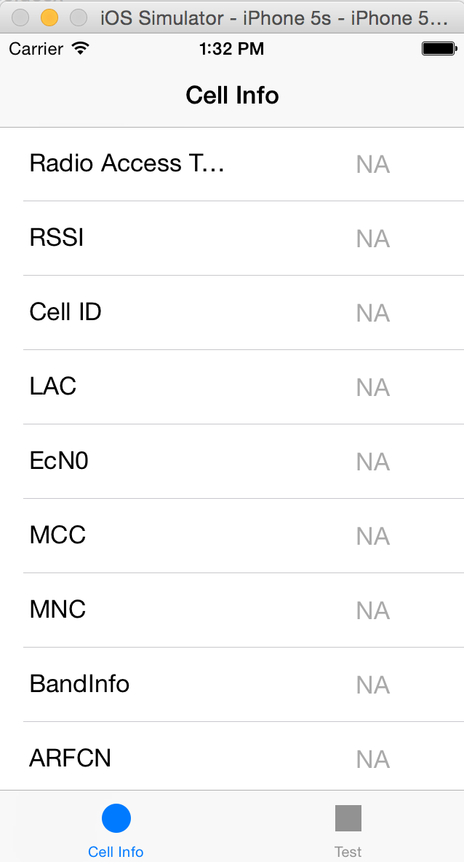

**Elements:**

Tab Bar: on the bottom, “Cell Info” and “Test”

Cell Info table view:

Cell: “Custom” style with 2 Labels—“Parameter name” and “NA”

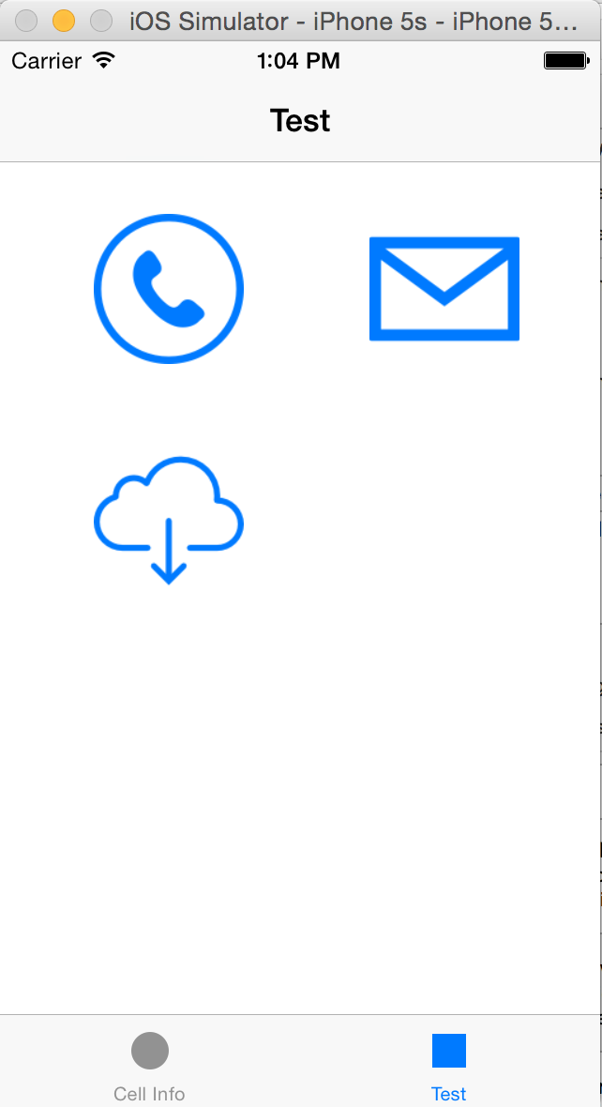

Test view:

White background

Image button(3):

“Call test”: not implemented here;

“Message test”: not implemented here;

“EMB test”: implemented, segue to the EMB test view

**EMBtest Page Design**

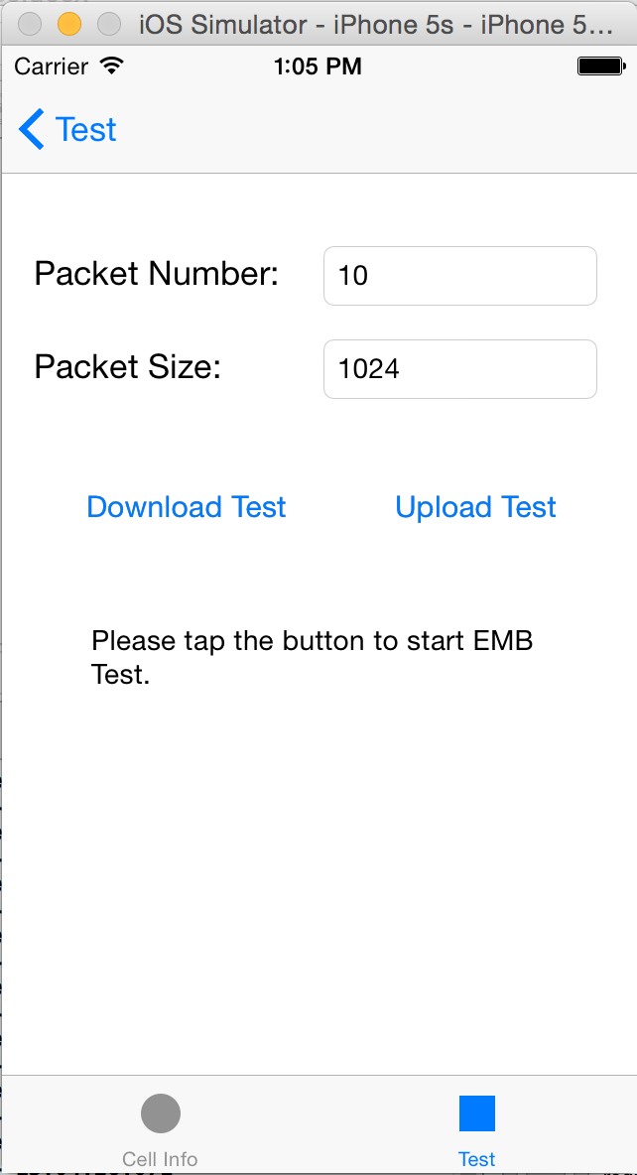**Elements:**

Background: white(default)

“Test” Button:

Navigation bar item, segue back to the test index page.

“Packet Number” label and “Packet Size” label : black text, size 17

“packetNumber” input text field: size 14, default text “10”

“packetSize” input text field: size 14, default text “1024”

“Download Test” button:

blue font

do the EMB download test; result will show in the bellow textview

“Upload Test” button:

blue font

do the EMB upload test; result will show in the bellow textview

“result display” textview: Initial value “Please tap the button to start EMB test”

show the process and speed of the tests

After tap the “Download Test” button(different speed):

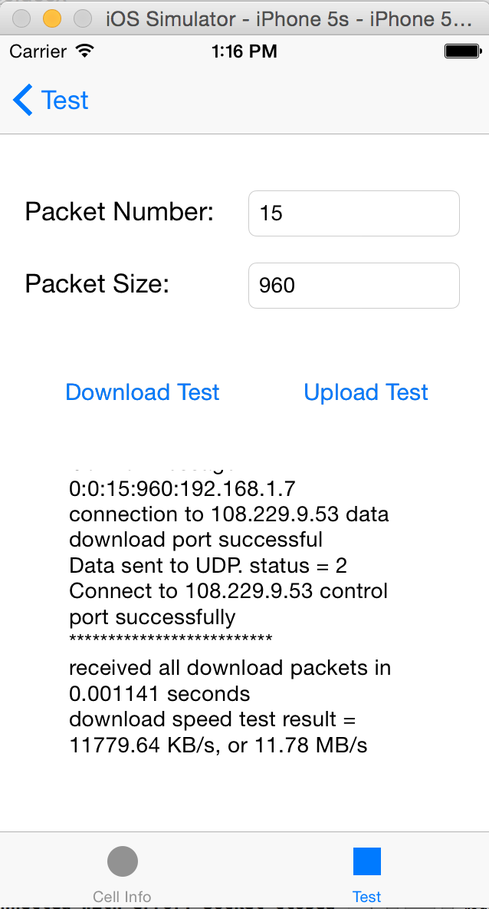

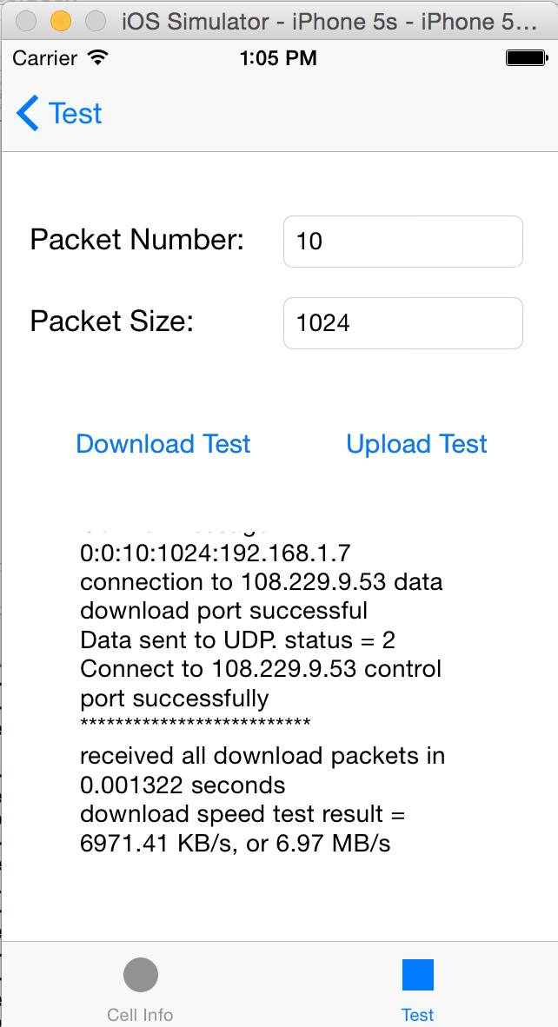

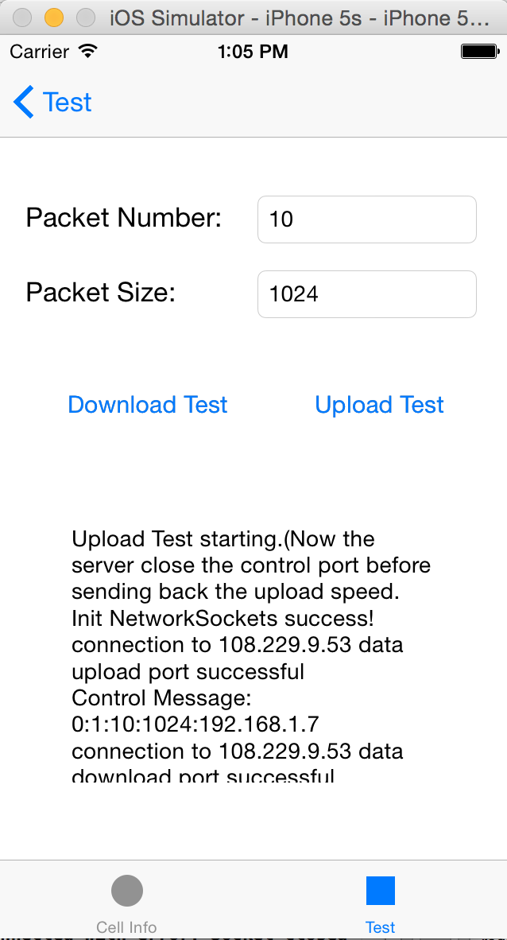After tap the “Upload Test” button:(no speed result due to the server error)